**STUDENT INFORMATION MANAGEMENT SYSTEM**

**ABSTRACT**

The Student Information Management System is a comprehensive web-based application designed to efficiently manage and monitor the academic progress of students. This system leverages HTML, CSS, Bootstrap for the frontend, and PHP and MySQL for the backend to provide an intuitive and feature-rich platform for educational institutions to track and enhance their students' Information.

Key Features:

1. User-friendly Dashboard: The system offers an intuitive dashboard for administrators, teachers, and students to access relevant information and perform various tasks.
2. Student Profile Management: Administrators can maintain detailed student profiles, including personal information, contact details, and academic history.
3. Course and Grading Management: Teachers can input course information, syllabi, and grading criteria, making it easy to manage and evaluate students' progress.
4. Information Analytics: The system calculates and displays students' grades, Information trends, and GPA, allowing for data-driven decision-making.
5. Secure User Authentication: User authentication and role-based access control ensure data security and privacy.
6. Data Backup and Recovery: Regular data backups and a recovery mechanism prevent data loss and ensure system reliability.
7. Responsive Design: The use of HTML, CSS, and Bootstrap ensures that the system is responsive, making it accessible on various devices and screen sizes.
8. Database Integration: PHP and MySQL are employed for robust backend data processing, storage, and retrieval.

In conclusion, the Student Information Management System is a powerful tool for educational institutions to effectively monitor and enhance student Information. The use of HTML, CSS, Bootstrap, PHP, and MySQL enables a user-friendly interface, secure data management, and a feature-rich environment that facilitates efficient communication and data-driven decision-making in the academic setting.

**INTRODUCTION**

In today's educational landscape, the effective management and assessment of student Information are essential for both students and educational institutions. To meet this demand, the Student Information Management System is designed to provide a comprehensive solution that leverages modern web development technologies such as HTML, CSS, Bootstrap, PHP, and MySQL. This system offers a powerful and user-friendly platform for schools, colleges, and universities to monitor, analyze, and improve student academic progress.

Academic success is a crucial goal for students and their educational institutions. The Student Information Management System aims to streamline the process of tracking and enhancing student Information. With the integration of HTML, CSS, Bootstrap, PHP, and MySQL, this system offers a wide range of features and functionalities that cater to the diverse needs of educators, administrators, teachers, and students.

As we delve deeper into the functionalities and benefits of the Student Information Management System, it becomes evident that it is not just a technological tool but a comprehensive solution aimed at improving educational outcomes. The system's integration of HTML, CSS, Bootstrap, PHP, and MySQL represents a commitment to user-friendly design, data security, and data-driven educational decision-making.

In a world where information and technology play a vital role in education, the Student Information Management System emerges as a valuable asset for educational institutions, students, and educators alike, helping them strive for higher academic achievements and improved educational experiences.

**SYSTEM ANALYSIS**

**EXISTING SYSTEM**

Currently, teachers and school administrators keep physical records to keep track of a student’s Information in examinations. These physical records can easily be destroyed or manipulated by external factors. This also costs more due to the usage of a lot of paper for keeping records.

**PROPOSED SYSTEM**

* **Efficient Data Management:** Implement a secure and efficient database system using MySQL to store and manage student information, academic records, and Information data.
* **User-Friendly Interface:** Develop a user-friendly, responsive front-end interface using HTML, CSS, and Bootstrap that is accessible on various devices, making it easy for users to navigate the system.
* **Information Tracking and Analysis:** Implement features for tracking student Information, including grade management, attendance monitoring, and Information analytics. This allows educators and administrators to make data-driven decisions to enhance educational outcomes.
* **Data Security:** Ensure the security of student data through user authentication and role-based access control, protecting sensitive information from unauthorized access.
* **Custom Reporting:** Create a report generation system that allows for the generation of customized reports, such as report cards and transcripts, for easy sharing with students and parents.
* **Integration of Technologies:** Leverage HTML, CSS, Bootstrap for the front-end to create an attractive and responsive user interface. Use PHP for the server-side scripting and MySQL for data storage, ensuring a seamless and integrated system.

**DESCRIPTION OF MODULES**

1. **User Authentication Module:**
   * Manages user registration, login, and logout functionalities for administrators.
   * Implements secure password storage and retrieval.
   * Differentiates between different user roles, such as administrators.
2. **Student Registration Module:**
   * Allows administrators to register new students by collecting their personal information, contact details, and academic details.
   * Provides validation checks to ensure accuracy and completeness of student information.
   * Generates a unique student ID for each registered student.
3. **Student Profile Management Module:**
   * Enables administrators to view, update, and manage student profiles.
   * Allows administrators to track academic performance, attendance records, and extracurricular activities.
   * Supports the upload of student photos and documents.
4. **Attendance Tracking Module:**
   * Allows administrators to take attendance for classes and record student attendance status.
   * Provides a calendar view to visualize attendance trends over time.
   * Generates reports on individual student attendance and class-wise attendance.
5. **Academic Performance Module:**
   * Enables administrators to input and manage student grades for courses, exams, and assignments.
   * Allows administrators to generate transcripts and academic reports for individual students.
   * Provides a graphical representation of academic performance.
6. **Student Enrollment and Course Registration Module:**
   * Allows administrators to enroll students in courses, specifying the academic year and semester.
   * Provides a platform for students to register for courses online, view available courses, and check their schedules.
   * Generates reports on course enrollments and availability.
7. **Student Search and Reporting Module:**
   * Enables administrators to search for students based on various criteria such as name, ID, or academic performance.
   * Provides customizable reporting tools for administrators to generate reports on student demographics, attendance, and academic performance.
   * Supports export options for sharing reports in different formats.
8. **Security Module:**
   * Implements robust security measures to protect student data and sensitive information.
   * Manages access control to ensure that only authorized administrators can view and update student information.
   * Regularly updates security protocols to address potential vulnerabilities.
9. **Database Management Module:**
   * Manages the storage and retrieval of student-related data using MySQL databases.
   * Ensures data integrity, reliability, and security.
   * Implements backup and recovery mechanisms to prevent data loss.

This modular breakdown provides a foundation for the development of a comprehensive Student Information Management System. The use of HTML, CSS, Bootstrap, PHP, and MySQL ensures a responsive and dynamic web application that efficiently manages student information and supports the academic administration processes.

**SYSTEM SPECIFICATION**

**HARDWARE SPECIFICATION**

|  |  |
| --- | --- |
| System | HP 15s |
| Processor | Ryzen 5 2.1 GHz |
| Storage | 512 GB SSD |
| RAM | 16 GB |
| Monitor | Integrated Monitor |
| Mouse | Integrated Trackpad |
| Keyboard | Integrated Keyboard |

**OPERATING SYSTEM**

|  |  |
| --- | --- |
| Operating System | Windows 11 |
| Front End | PHP Version 8 |
| Back End | MySQL Version 8 |
| Server | XAMPP |

**SOFTWARE SPECIFICATION**

**SOFTWARE DESCRIPTION**

**XAMPP:**

XAMPP is an [open-source](https://en.wikipedia.org/wiki/Free_software) [cross-platform](https://en.wikipedia.org/wiki/Cross-platform) [web server](https://en.wikipedia.org/wiki/Web_server) [solution stack](https://en.wikipedia.org/wiki/Solution_stack) package developed by Apache Friends, consisting mainly of the [Apache HTTP Server](https://en.wikipedia.org/wiki/Apache_HTTP_Server), [Maria DB](https://en.wikipedia.org/wiki/MariaDB) [database](https://en.wikipedia.org/wiki/Database), and [interpreters](https://en.wikipedia.org/wiki/Interpreter_%28computing%29) for scripts written in the [PHP](https://en.wikipedia.org/wiki/PHP) and [Perl](https://en.wikipedia.org/wiki/Perl) [programming languages](https://en.wikipedia.org/wiki/Programming_language). XAMPP stands for Cross-Platform (X), Apache (A), Maria DB (M), PHP (P), and Perl (P). It is a simple, lightweight Apache distribution that makes it extremely easy for developers to create a local web server for testing and deployment purposes.

Everything needed to set up a web server – server application (Apache), database (Maria DB), and scripting language (PHP) – is included in an extractable file. XAMPP is also cross-platform, which means it works equally well on Linux, Mac, and Windows.

XAMPP's designers intended it for use only as a development tool, to allow website designers and programmers to test their work on their computers without any access to the Internet.

**CROSS-PLATFORM**

Cross-platform software is a type of software application that works on multiple operating systems or devices, which are often referred to as platforms. A platform means an operating system such as Windows, Mac OS, Android, or iOS. When a software application works on more than one platform, the user can utilize the software on a wider choice of devices and computers.

**BENEFITS OF CROSS-PLATFORM**

The benefit of a cross-platform software app or program is that you can use the same program whether you’re on a Windows PC or whether you’re logging in from your laptop or smartphone. The Microsoft Office suite of applications, which includes Word, Excel, and PowerPoint, is available on Windows, Mac OS, iOS (iPhone/iPad), and Android. While there are differences based on how the platforms work, you’ll have a similar experience within the application between all of your devices.

Having a similar experience across any platform means there’s a much smaller learning curve if one even exists at all, so you’ll be more productive and be able to use a software product you’re familiar with regardless of the operating system or device you choose. In addition, your files can be moved much more easily between your devices so you can use the software with whatever device you have with you at the time. And there’s a way to keep all of your work in sync across all of your devices, by using the cloud.

**EXAMPLES OF CROSS-PLATFORM**

**Unity 3D**

First, let’s talk about Unity3D. I think the game engine should be preferred by people who want to write mobile games.  
You can develop games on 17 platforms using multiple languages, including Linux. Of course, iOS, Android, and Windows Phone is also the most ideal game engine to develop games.

You can develop your application using C #, JS, and C ++.

Link to: [https://unity3d.com](https://unity3d.com/)

# Xamarin

Xamarin Some time ago, it was purchased by Microsoft and is a perfect fit for developers using C #.

Because it is a C # language, it has a lot of documentation, and because of Microsoft support, Xamarin is the choice for C # developers.

In addition, you can do everything you can do in Objective-C, Swift, and Java with the Xamarin library.

Link to: [https://xamarin.com](https://xamarin.com/)

# React Native

React Native is an open-source JavaScript library developed by the new generation of React — Facebook, which was open to Github in 2013. Native application creation means writing applications only for a specific operating system. React Native helps developers reuse their code over the web and on mobile. Developers will not have to create the same app from scratch for iOS and Android. They will be able to reuse the code in each operating system. The great thing about React Native is that there is little difference between a finished application in Objective-C or Java and an application built using React Native. Android and iOS code development environments are very different. So it takes time to remove the application to two different platforms. However, with React Native, only one developer can write on different mobile operating systems.

**APACHE:**

The Apache HTTP Server, colloquially called Apache is a [free and open-source](https://en.wikipedia.org/wiki/Free_and_open-source) [cross-platform](https://en.wikipedia.org/wiki/Cross-platform) [web server](https://en.wikipedia.org/wiki/Web_server) software, released under the terms of [Apache License](https://en.wikipedia.org/wiki/Apache_License) 2.0. Apache is developed and maintained by an open community of developers under the auspices of the [Apache Software Foundation](https://en.wikipedia.org/wiki/Apache_Software_Foundation).

The vast majority of Apache HTTP Server instances run on a [Linux distribution](https://en.wikipedia.org/wiki/Linux_distribution), but current versions also run on [Microsoft Windows](https://en.wikipedia.org/wiki/Microsoft_Windows), [OpenVMS](https://en.wikipedia.org/wiki/OpenVMS),  and a wide variety of [Unix-like](https://en.wikipedia.org/wiki/Unix-like) systems. Past versions also ran on [NetWare](https://en.wikipedia.org/wiki/NetWare), [OS/2](https://en.wikipedia.org/wiki/OS/2), and other operating systems,  including ports to mainframes.

Originally based on the HTTP server, the development of Apache began in early 1995 after work on the NCSA code stalled. Apache played a key role in the initial growth of the [World Wide Web](https://en.wikipedia.org/wiki/World_Wide_Web), quickly overtaking NCSA HTTP as the dominant [HTTP](https://en.wikipedia.org/wiki/HTTP) server. In 2009, it became the first web server software to serve more than 100 million [websites](https://en.wikipedia.org/wiki/Website). As of January 2021, [Netcraft](https://en.wikipedia.org/wiki/Netcraft" \o "Netcraft) estimated that Apache served 24.63% of the million busiest websites, while [Nginx](https://en.wikipedia.org/wiki/Nginx) served 23.21% and Microsoft is in third place at 6.85% (for some of Netcraft's other stats Nginx is ahead of Apache), while according to W3Techs, Apache is ranked first at 35.0% and Nginx second at 33.0% and Cloudflare Server third at 17.3%.

**LANGUAGE SPECIFICATION**

**PHP**

**INTRODUCTION OF PHP**

PHP started as a small open-source project that evolved as more and more people found out how useful it was. Rasmus Lerdorf unleashed the first version of PHP way back in 1994.

* PHP is a recursive acronym for "PHP: Hypertext Preprocessor".
* PHP is a server-side scripting language that is embedded in HTML. It is used to manage dynamic content, databases, session tracking, and even build entire e-commerce sites.
* It is integrated with several popular databases, including MySQL, PostgreSQL, Oracle, Sybase, Informix, and Microsoft SQL Server.
* PHP is pleasingly zippy in its execution, especially when compiled as an Apache module on the Unix side. The MySQL server, once started, executes even very complex queries with huge result sets in record-setting time.
* PHP supports a large number of major protocols such as POP3, IMAP, and LDAP. PHP4 added support for Java and distributed object architectures (COM and CORBA), making n-tier development a possibility for the first time.
* PHP is forgiving: PHP language tries to be as forgiving as possible.
* PHP Syntax is the same as C language.

**What is a PHP File?**

* PHP files can contain text, HTML, CSS, JavaScript, and PHP code.
* PHP code is executed on the server, and the result is returned to the browser as plain HTML.
* PHP files have the extension ".php".

**What Can PHP Do?**

* PHP can generate dynamic page content and it can create, open, read, write, delete, and close files on the server and it can collect form data.
* PHP can send and receive cookies it can add, delete, and modify data in your database and it can be used to control user-access and encrypt data.

**Why PHP?**

* PHP runs on various platforms (Windows, Linux, Unix, Mac OS X, etc.).
* PHP is compatible with almost all servers used today (Apache, IIS, etc.).
* PHP supports a wide range of databases.
* PHP is free.
* PHP is easy to learn and runs efficiently on the server side.

## **What is a Database?**

* A database is a separate application that stores a collection of data. Each database has one or more distinct APIs for creating, accessing, managing, searching, and replicating the data it holds.
* Other kinds of data stores can be used, such as files on the file system or large hash tables in memory but data fetching and writing would not be so fast and easy with those types of systems.
* Nowadays, we use relational database management systems (RDBMS) to store and manage huge volumes of data. This is called a relational database because all the data is stored in different tables and relations are established using primary keys or other keys known as foreign keys.

**MySQL Database**

* MySQL is released under an open-source license. So you have nothing to pay to use it. MySQL is a very powerful program in its own right. It handles a large subset of the functionality of the most expensive and powerful database packages.
* MySQL uses a standard form of the well-known SQL data language. MySQL works on many operating systems and with many languages including PHP, PERL, C, C++, JAVA, etc. MySQL works very quickly and works well even with large data sets.
* MySQL is very friendly to PHP, the most appreciated language for web development. MySQL supports large databases, up to 50 million rows or more in a table.
* The default file size limit for a table is 4GB, but you can increase this (if your operating system can handle it) to a theoretical limit of 8 million terabytes (TB). MySQL is customizable.
* The open-source GPL license allows programmers to modify the MySQL software to fit their specific environments.

**TABLE CREATION**

* Name of the table
* Names of fields
* Definitions for each field
* Field Attribute **NOT NULL** is being used because we do not want this field to be NULL. So if the user tries to create a record with a NULL value, then MySQL will raise an error.
* Field Attribute **AUTO_INCREMENT** tells MySQL to go ahead and add the next available number to the id field.
* Keyword **PRIMARY KEY** is used to define a column as the primary key. You can use multiple columns separated by a comma to define a primary key.

## **ADMINISTRATIVE MYSQL COMMAND**

* **USE DATABASE NAME**: This will be used to select a particular database in the MySQL work area.
* **SHOW DATABASES:** Lists the databases that are accessible by the MySQL DBMS.
* **SHOW TABLES:** Shows the tables in the database once a database has been selected with the use command.
* **SHOW COLUMNS FROM Table name:** Shows the attributes, types of attributes, key information, whether NULL is permitted, defaults, and other information for a table.
* **SHOW INDEX FROM Table name:** Presents the details of all indexes on the table, including the PRIMARY KEY

## **CREATING TABLES USING PHP SCRIPT:**

To create a new table in any existing database you would need to use PHP function **mysqli_query()**.

## **Dropping Tables Using PHP Script:**

Drop an existing table in any database, you would need to use the PHP function **mysqli_query()**.

## **INSERTING DATA USING PHP SCRIPT:**

**CREATE**

Create table statement is used to create a table in MySQL.

**SELECT**

The SELECT statement is used to select data from one or more tables.

**UPDATE**

The UPDATE statement is used to update existing records in a table:

## **DELETE**

The DELETE statement is used to delete records from a table:

**DATABASE DESIGN:**

The data in the system has to be stored and retrieved from the database. Designing the database is part of system design. Data elements and data structures to be stored have been identified at the analysis stage.

They are structured and put together to design the data storage and retrieval system. A database is a collection of interrelated data stored with minimum redundancy to serve many users quickly and efficiently.

The general objective is to make database access easy, quick, inexpensive, and flexible for the user. Relationships are established between the data items and unnecessary data items are removed.

Normalization is done to get an internal consistency of data and to have minimum redundancy and maximum stability. This ensures minimizing data storage required, minimizing chances of data inconsistencies, and optimizing for updates.

**INPUT DESIGN**

The Input design is the main feature of the system. Input design determines the format and validation criteria for data entering the system. Inputs originate with end-users; human factors play a significant role in input design. The input design is designed to control the input, avoid delay, and errors in data, avoid extra steps, to keep the process simple. The design of input focuses on controlling the amount of input required, controlling the errors, avoiding delay, avoiding extra steps, and keeping the process simple. The input is designed in such a way that it provides security and ease of use while retaining privacy.

The following are the general principles, that are considered in designing inputs,

* + - Enter only variable data
    - Do not input data that can be calculated
    - List of values
    - Sequence entry

**OUTPUT DESIGN**

Designing the output is more important than working up with a few layout charts and reports. The outputs are designed based on the issue encountered. It will also take care of who will receive the output, what for it is produced how many details are needed, when it is needed, and by what method.

The outputs designed in this system are easy to use and useful for their jobs. The outputs are simple to read and interpret. The outputs obtained from this system are designed by using a few guidelines, which are given below. The information should be clear and accurate, yet concise and restricted to relevant data. Reports should have titles, data, and descriptive headings for columns of data, numbered pages, and so on.

**SYSTEM TESTING**

System testing is the process of exercising software with the intent of finding and ultimately correcting errors. This fundamental philosophy does not change for web applications, because Web-based systems and applications reside on a network and interoperate with many different operating systems, browsers, hardware platforms, and communication protocols; the search for errors represents a significant challenge for web applications.

The distributed nature of client/server environments, the Information issues associated with transaction processing, the potential presence of several different hardware platforms, the complexities of network communication, the need to serve multiple clients from a centralized database, and the requirements imposed on the server all combine to make testing of client\server architectures.

Testing issues

* Client GUI considerations
* Target environment and platform diversity considerations
* Distributed database considerations
* Distributed processing considerations

**TYPES OF TESTING**

1. Unit Testing

2. Integration Testing

3. Validation Testing

4. User Acceptance Testing

5. System Testing

**Unit Testing**

All modules were tested and individually as soon as they were completed were checked for their correct functionality. Unit testing is carried out by verifying and recovering errors within the boundary of the smallest unit or a module. In this testing step, each module was found to be working satisfactorily per the expected output of the module. In the package development, each module is tested separately after it has been completed and checked with valid data.

**Integration Testing**

The entire project was split into small programs; each of these single programs gives a frame as an output. These programs were tested individually; at last, all these programs were combined by creating another program where all these constructions were used. It causes a lot of problems by not functioning in an integrated manner.

The user interface testing is important since the user has to declare that the arrangements made in the frames are convenient and it is satisfied. When the frames are tested, the end user gives suggestions. Since they were much exposed to do the work manually.

**Validation Testing**

At the culmination of the black box testing software is completely assembled as a package. Interfacing errors have been uncovered and corrected and a final series of tests i.e., validation succeeds when the software functions in a manner that can be reasonably accepted by the customer.

**User Acceptance Testing**

User acceptance testing of the system is the key factor in the success of any system. The system under consideration is tested for user acceptance by constantly keeping in touch with prospective systems at the time of development and making changes whenever required. This is done concerning the input screen design and output screen design.

**System Testing**

This is to verify that all the system elements have been properly integrated and perform allocated functions. Testing is executing a program to test the logic changes made in it to find errors. Tests are also conducted to find discrepancies between the system and its original objective, current specifications, and documents.

**SYSTEM IMPLEMENTATION**

Implementation is the stage in the project where the theoretical design is turned into a working system. The most crucial stage is achieving a successful new system & and giving the user confidence that the new system will work efficiently & and effectively in the implementation stage.

The stage consists of

* + - Testing the developed program with simple data.
    - Detections and correction of errors.
    - Creating whether the system meets user requirements.
    - Testing whether the system.
    - Making necessary changes as desired by the user.
    - Training user personnel.

**Implementation Procedures**

The implementation phase is less creative than the system design. A system project may be dropped at any time before implementation, although it becomes more difficult when it goes to the design phase.

The final report to the implementation phase includes procedural flowcharts, record layouts, report layouts, and a workable plan for implementing the candidate system design into an operational one. Conversion is one aspect of implementation.

**System Maintenance**

Maintenance is the implementation of the review plan. As important as it is, many programmers and analysts are to perform or identify themselves with the maintenance effort. There are psychological, personality, and professional reasons for this. Analysts and programmers spend far more time maintaining programs than they do writing them. Maintenance accounts for 50-80 percent of total system development.

Maintenance is expensive. One way to reduce maintenance costs is through maintenance management and software modification audits.

* Maintenance is not as rewarding or exciting as developing systems. It is perceived as requiring neither skill nor experience.
* Users are not fully cognizant of the maintenance problem or its high cost.
* Few tools and techniques are available for maintenance.
* A good test plan is lacking.
* Standards, procedures, and guidelines are poorly defined and enforced.
* Programs are often maintained without care for structure and documentation.
* There are minimal standards for maintenance.
* Programmers expect that they will not be in their current commitment by the time their programs go into the maintenance cycle.

**SYSTEM DESIGN**

System design is "the process of studying a procedure or business to identify its goals, purposes and create systems and procedures that will efficiently achieve them". Another view sees system analysis as a problem-solving technique that breaks down a system into its component pieces for the study of how well those parts work and interact to accomplish their purpose.

The field of system analysis relates closely to requirements analysis or operations research. It is also "an explicit formal inquiry carried out to help a decision maker identify a better course of action and make a better decision than they might otherwise have made."

* **DESIGN NOTATION**

Design notations are used when planning and should be able to communicate the purpose of a program without the need for formal code. Commonly used design notations are:

* DFD
* ERD
* **DFD (DATA FLOW DIAGRAM):**

A data flow diagram (DFD) is a graphical representation of the "flow" of data through an [information system](https://en.wikipedia.org/wiki/Information_system), modeling its process aspects. A DFD is often used as a preliminary step to create an overview of the system without going into great detail, which can later be elaborated. DFDs can also be used for the [visualization](https://en.wikipedia.org/wiki/Data_visualization) of [data processing](https://en.wikipedia.org/wiki/Data_processing) (structured design). A DFD shows what kind of information will be input to and output from the system, how the data will advance through the system, and where the data will be stored. It does not show information about the timing of the process or information about whether processes will operate in sequence or parallel, unlike a [flowchart](https://en.wikipedia.org/wiki/Flowchart) which also shows this information.

Data flow diagrams were popularized in the late 1970s, arising from the book Structured Design, by computing pioneers Ed Yourdon and Larry Constantine. They based it on the “data flow graph” computation models by David Martin and Gerald Estrin. The structured design concept took off in the software engineering field, and the DFD method took off with it. It became more popular in business circles, as it was applied to business analysis than in academic circles.

**DFD SYMBOLS**

The process that transforms data flow

Source or Destination of Data

Data Flow

Data source

**ENTITY RELATIONSHIP DIAGRAM**

The relation upon the system is structured through a conceptual ER-Diagram, which not only specifies the existential entities but also the standard relations through which the system exists and the cardinalities that are necessary for the system state to continue. The Entity Relationship Diagram (ERD) depicts the relationship between the data objects. The ERD is the notation that is used to conduct the data modeling activity The attributes of each data object noted in the ERD can be described resign a data object description.

The set of primary components that are identified by the ERD are

* + Data object
  + Relationships
  + Attributes
  + Various types of indicators

The primary purpose of the ERD is to represent data objects and their relationships.

**ER-DIAGRAM SYMBOL**

Entity

Relationship

Flow

**INPUT DESIGN**

The input design is the link between the information system and the user. It comprises the developing specifications and procedures for data preparation and those steps are necessary to put transaction data into a usable form for processing can be achieved by inspecting the computer to read data from a written or printed document or it can occur by having people keying the data directly into the system. The design of input focuses on controlling the amount of input required, controlling the errors, avoiding delay, avoiding extra steps, and keeping the process simple. The input is designed in such a way that it provides security and ease of use while retaining privacy.

Input Design is the process of converting a user-oriented description of the input into a computer-based system. This design is important to avoid errors in the data input process and show the correct direction to the management for getting correct information from the computerized system. It is achieved by creating user-friendly screens for the data entry to handle large volumes of data.

The goal of designing input is to make data entry easier and to be free from errors. The data entry screen is designed in such a way that all the data manipulations can be performed. It also provides record viewing facilities. When the data is entered it will check for its validity. Data can be entered with the help of screens.

**DATABASE DESIGN**

The database is designed to manage large bodies of information. The management of data involves both the definitions of structures for the storage of information. In addition, the database system must provide for the safety of the information solved, despite system crashes or attempts at unauthorized access. For developing an efficient database users have to fulfill certain conditions such as controlled redundancy.

* Defining the data
* Inputting the data
* Locating the data
* Accessing the data
* Communicating the data

Revising the data

**Objectives of Database Design**

For designing a database design several objectives have to be met as follows:

* Ease of use
* Control of data integrity
* Control of redundancy
* Control of security
* Data independence (logical & physical)
* Data storage protection
* System Information

**OUTPUT DESIGN**

A quality output is one, which meets the requirements of the end user and presents the information. In any system results of processing are communicated to the users and other systems through outputs. In output design it is determined how the information is to be displaced for immediate need and also the hard copy output. It is the most important and direct source of information to the user. Efficient and intelligent output design improves the system’s relationship to help user decision-making.

Output design generally refers to the results and information that are generated by the system for many end-users; output is the main reason for developing the system and the basis on which they evaluate the usefulness of the application.

In this Online Repository System project output is to view customer details, employee lists, order tracking details, and attendance percentage results.

**SYSTEM FLOW DIAGRAM**

**DATA FLOW DIAGRAM**

Student

Admin

Logs in and adds results, students, class and subjects

Displays result and performance

Displays stored data in database

Logs in using roll number

**ER DIAGRAM**

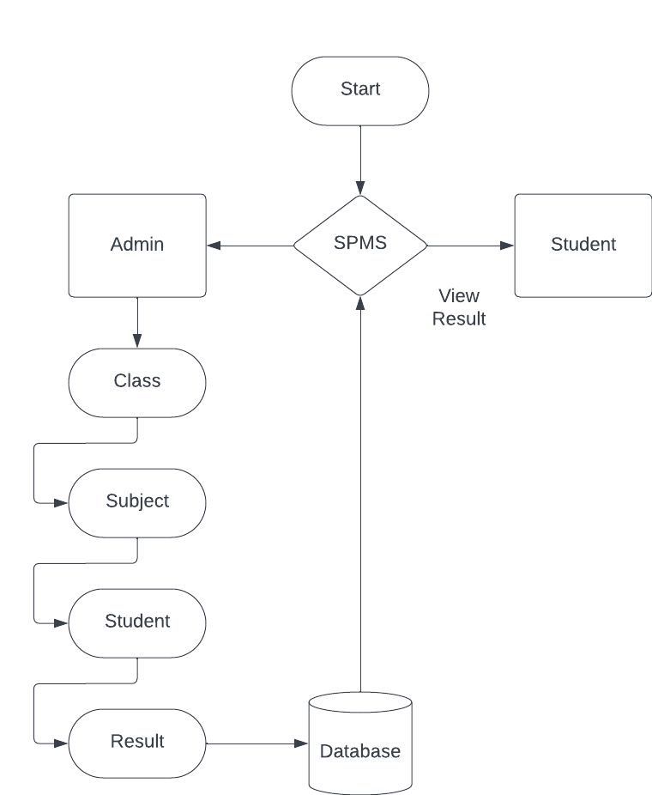

**DATABASE DESIGN**

**Table name: admin**

|  |  |  |  |
| --- | --- | --- | --- |
| **FIELD NAME** | **DATA TYPE** | **LENGTH** | **DESCRIPTION** |
| id | int | 10 | unique id |
| UserName | varchar | 255 | Admin name |
| Password | varchar | 255 | Admin password |
| updationDate | varchar | 255 | Update date |

**Table name: tblnotice**

|  |  |  |  |
| --- | --- | --- | --- |
| **FIELD NAME** | **DATA TYPE** | **LENGTH** | **DESCRIPTION** |
| id | int | 10 | unique id |
| noticeTitle | varchar | 255 | Title |
| noticeDetails | varchar | 255 | Notice contents |
| postingDate | varchar | 255 | Posting date |

**CONCLUSION**

In conclusion, the Student Information Management System, built upon a foundation of HTML, CSS, Bootstrap, PHP, and MySQL, stands as a transformative solution for educational institutions seeking to improve the management and assessment of student Information. This system offers a powerful, user-friendly, and integrated platform to meet the diverse needs of students, teachers, and administrators.

By integrating modern web technologies, this system facilitates efficient data management, responsive user interfaces, Information tracking and analysis, and secure communication.

By seamlessly integrating HTML, CSS, Bootstrap, PHP, and MySQL, the Student Information Management System not only enhances educational management but also contributes to a more productive and engaging educational experience. It streamlines administrative tasks, supports data-driven decision-making, and fosters transparent communication between all stakeholders.

As educational institutions continue to adapt to the ever-evolving digital landscape, the Student Information Management System provides a reliable and versatile solution to meet the demands of modern education. It ultimately aids in the pursuit of higher academic achievements and the improvement of the overall educational experience for students, teachers, and administrators alike.

**SCREENSHOTS**

**Student Login**

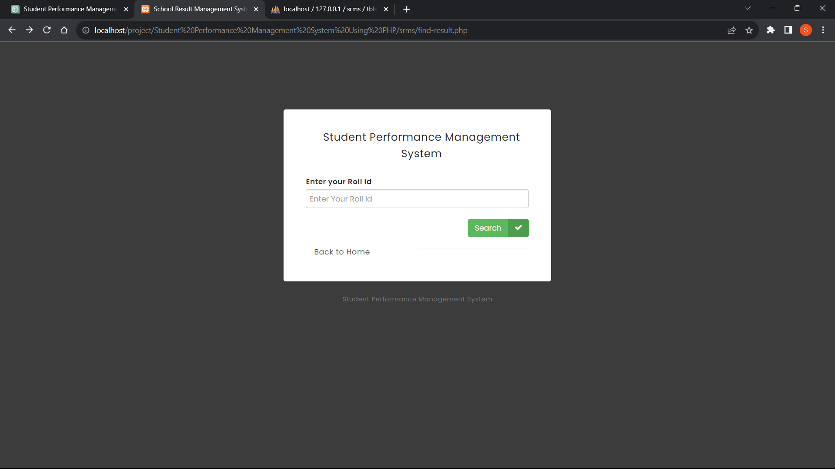

**Index Page**

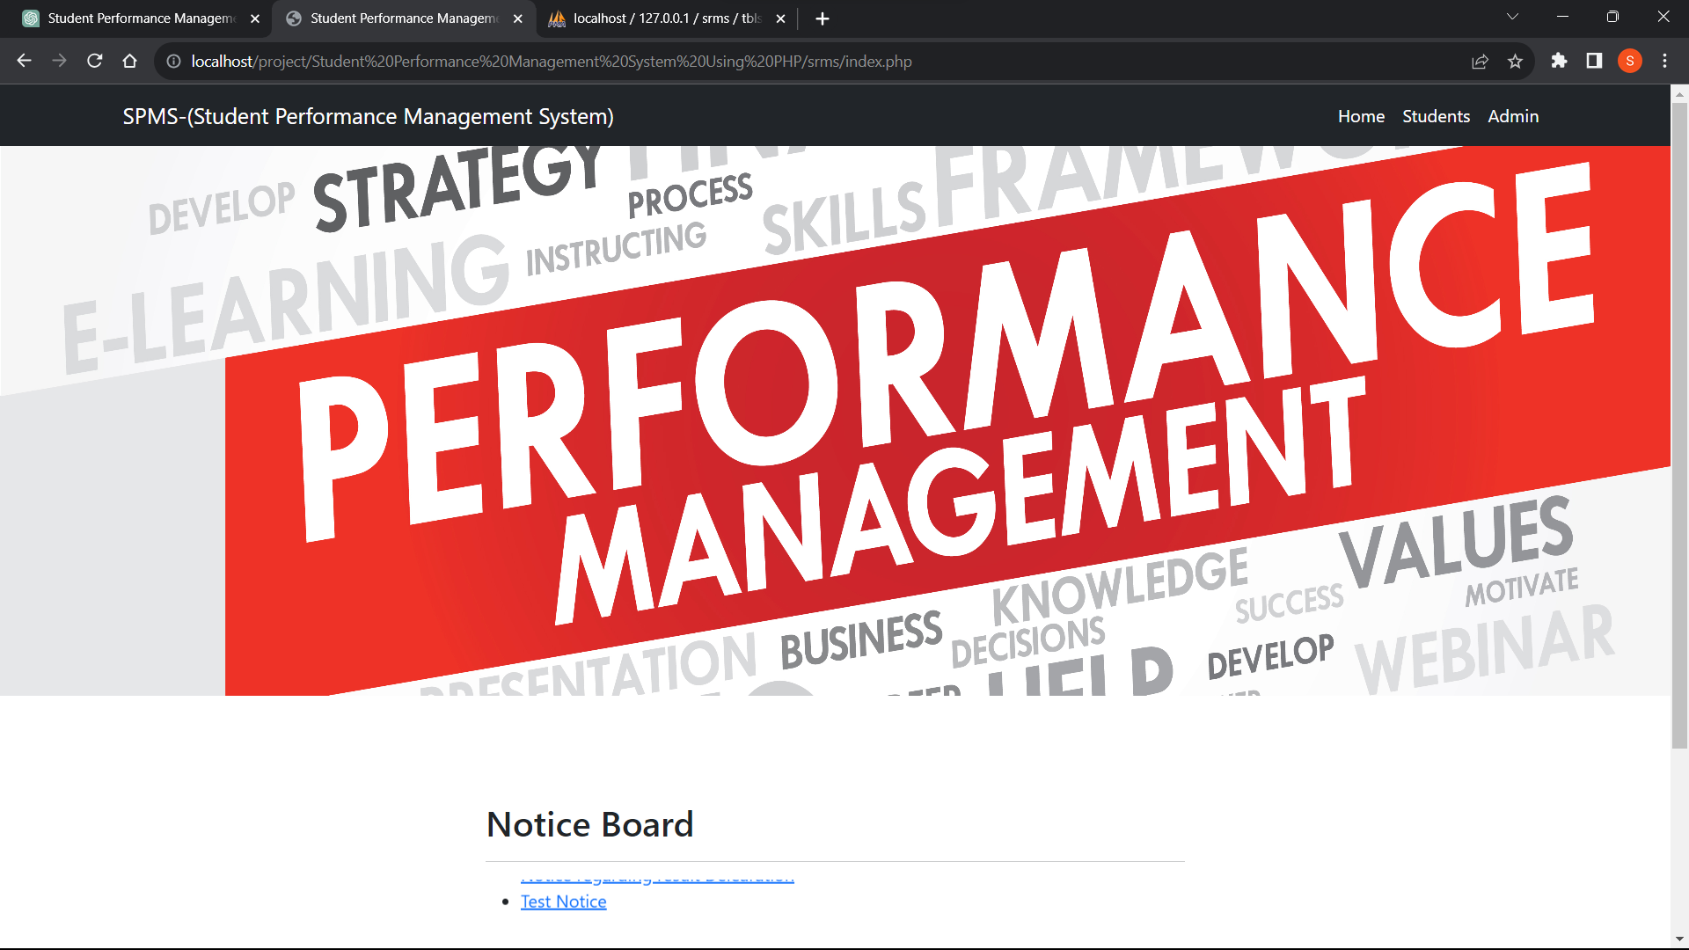

**Information page**

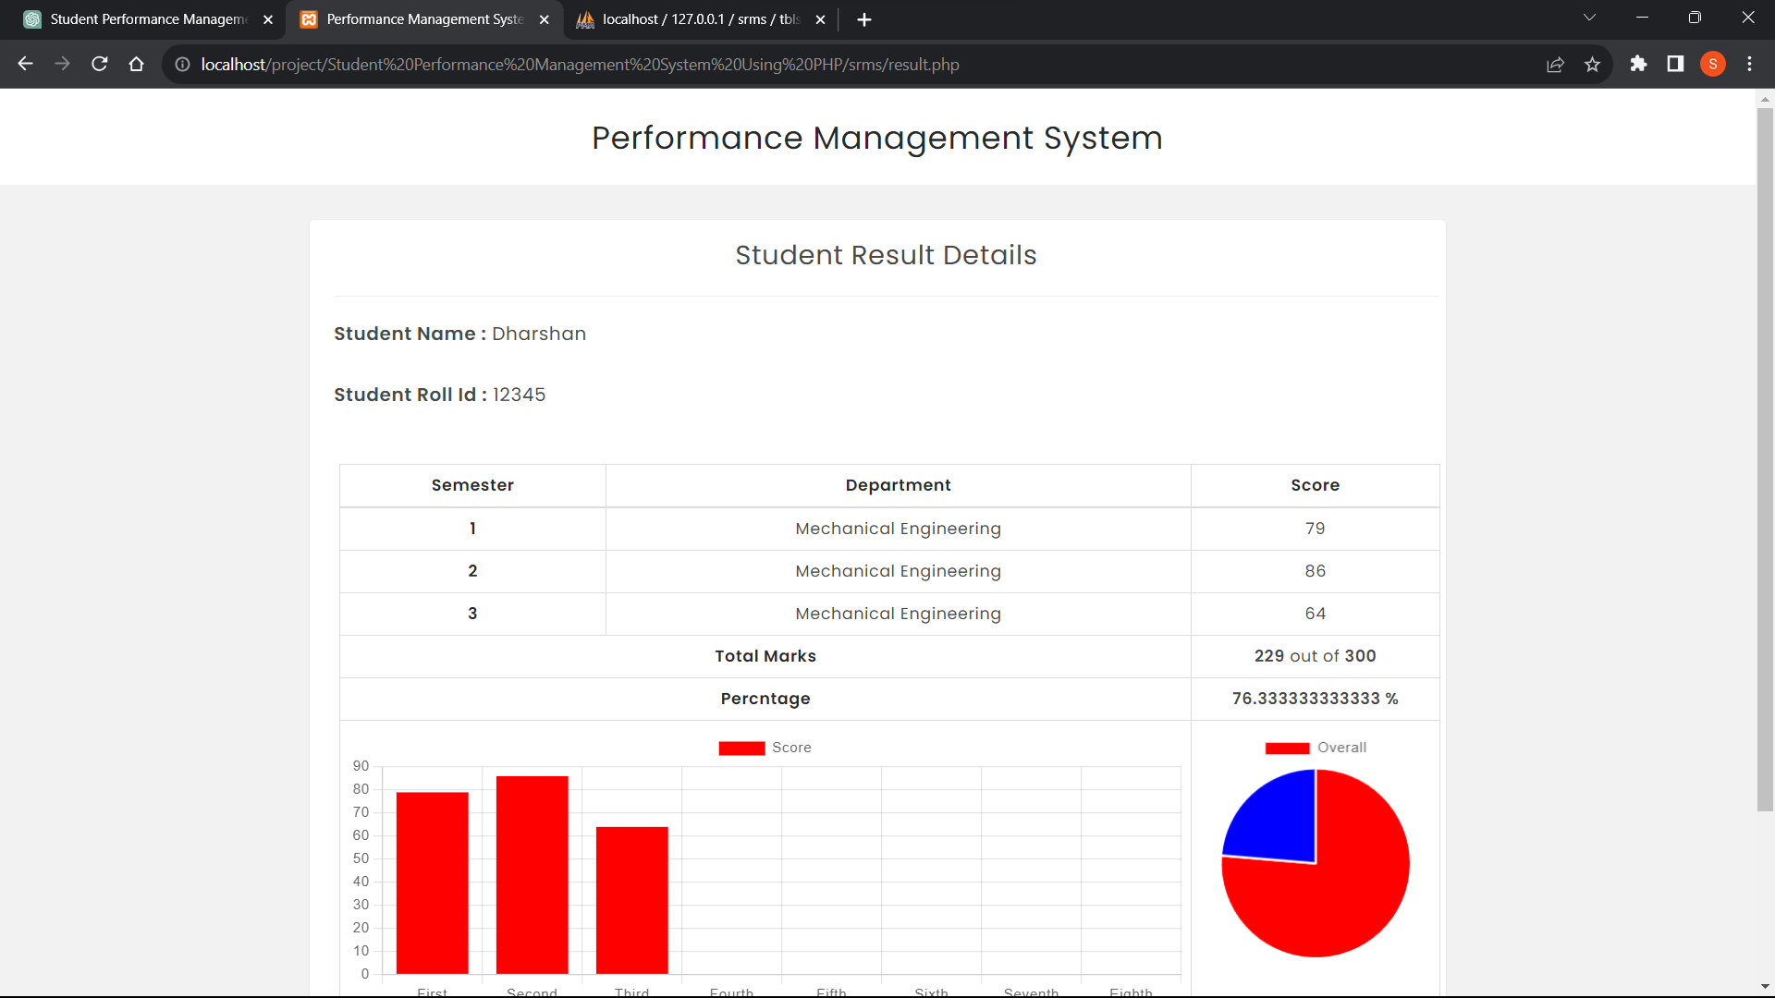

**Admin Login**

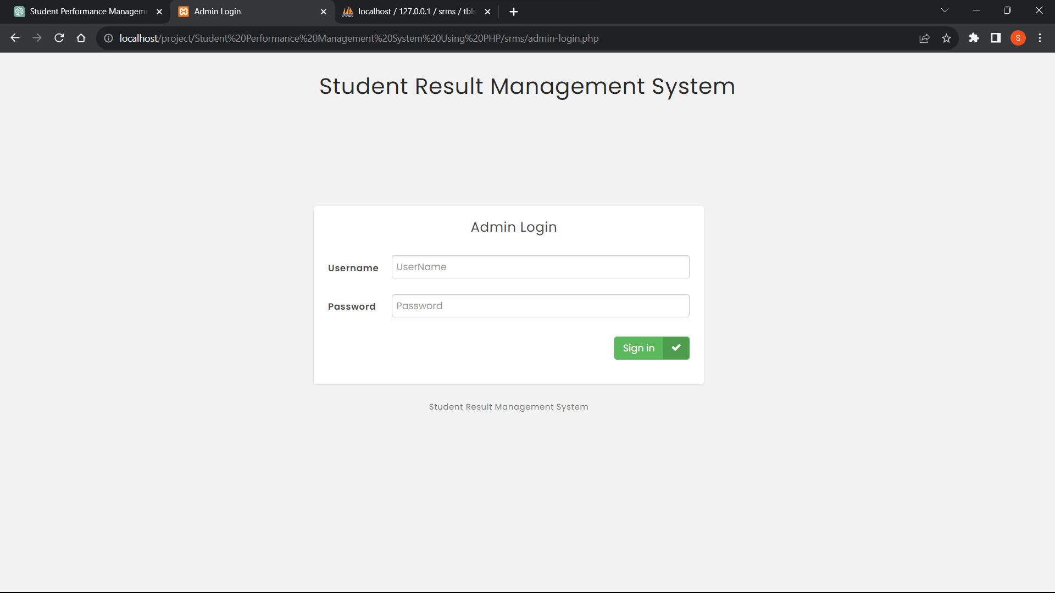

**Admin Dashboard**

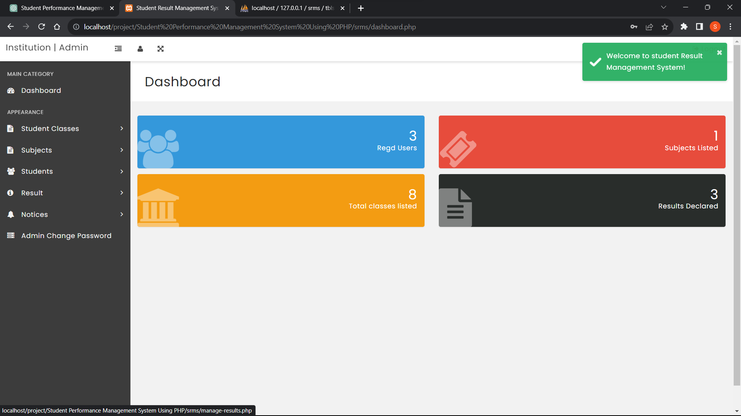

**Manage results page**

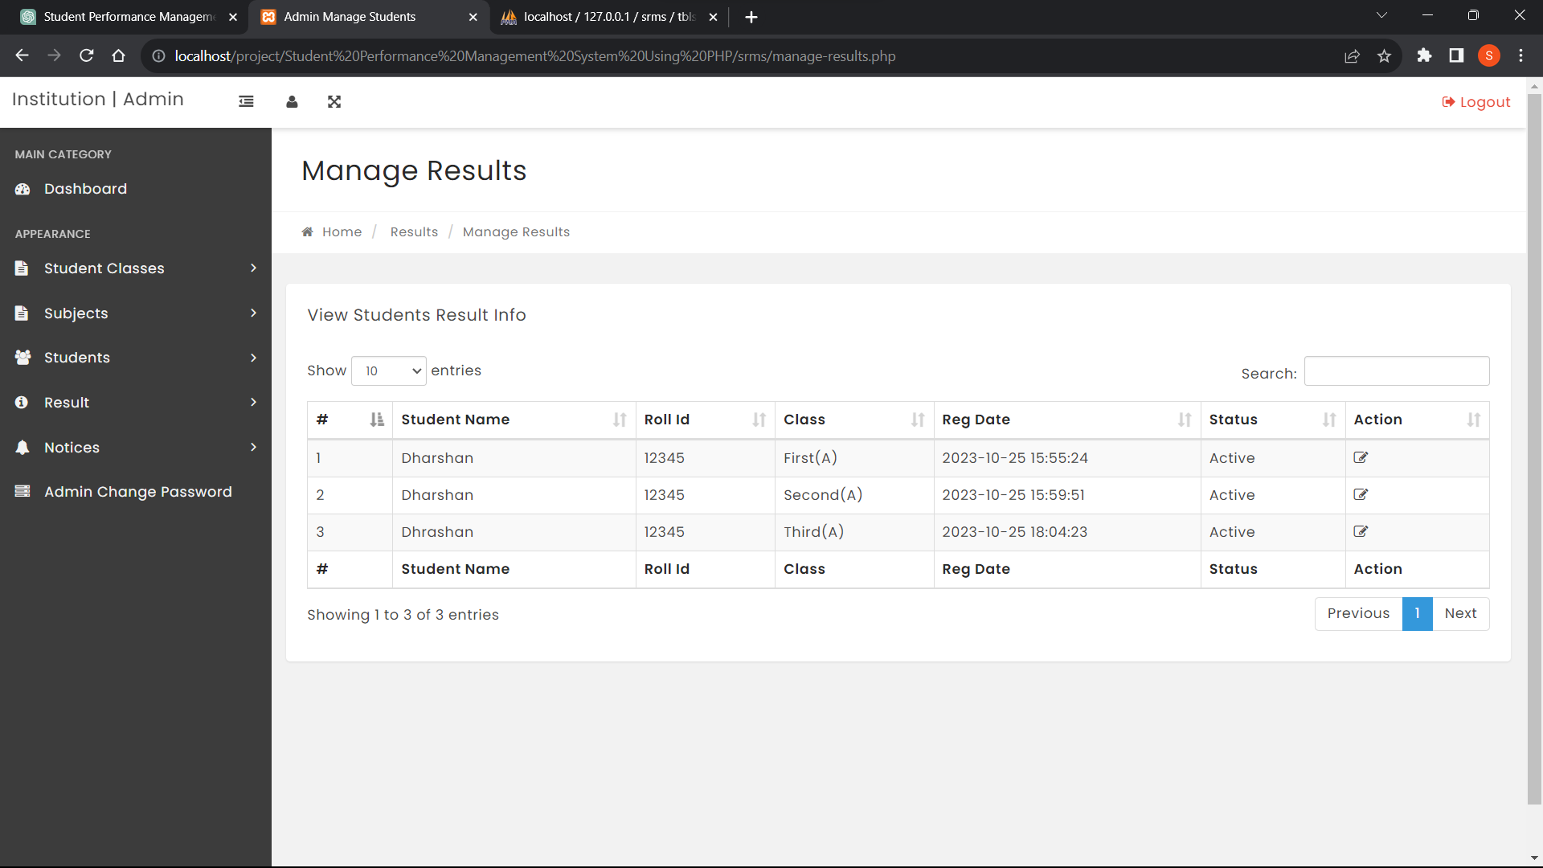

**SAMPLE CODE**

**<?php**

**error_reporting(0);**

**include('includes/config.php');**

**?>**

**<!DOCTYPE html>**

**<html lang="en">**

**<head>**

**<meta charset="utf-8" />**

**<meta name="viewport" content="width=device-width, initial-scale=1, shrink-to-fit=no" />**

**<meta name="description" content="" />**

**<meta name="author" content="" />**

**<title>Student Information Management System</title>**

**<!-- Favicon-->**

**<link rel="icon" type="image/x-icon" href="assets/favicon.ico" />**

**<!-- Core theme CSS (includes Bootstrap)-->**

**<link href="css/styles.css" rel="stylesheet" />**

**</head>**

**<body>**

**<!-- Responsive navbar-->**

**<nav class="navbar navbar-expand-lg navbar-dark bg-dark">**

**<div class="container">**

**<a class="navbar-brand" href="index.php">SPMS-(Student Information Management System)</a>**

**<button class="navbar-toggler" type="button" data-bs-toggle="collapse" data-bs-target="#navbarSupportedContent" aria-controls="navbarSupportedContent" aria-expanded="false" aria-label="Toggle navigation"><span class="navbar-toggler-icon"></span></button>**

**<div class="collapse navbar-collapse" id="navbarSupportedContent">**

**<ul class="navbar-nav ms-auto mb-2 mb-lg-0">**

**<li class="nav-item"><a class="nav-link active" aria-current="page" href="index.php">Home</a></li>**

**<li class="nav-item"><a class="nav-link active" href="find-result.php">Students</a></li>**

**<li class="nav-item"><a class="nav-link active" href="admin-login.php">Admin</a></li>**

**</ul>**

**</div>**

**</div>**

**</nav>**

**<!-- Header - set the background image for the header in the line below-->**

**<header class="py-5 bg-image-full" style="background-image: url('images/background-image.jpg')">**

**</header>**

**<!-- Content section-->**

**<section class="py-5">**

**<div class="container my-5">**

**<div class="row justify-content-center">**

**<div class="col-lg-6">**

**<h2>Notice Board</h2>**

**<hr color="#000" />**

**<marquee direction="up" onmouseover="this.stop();" onmouseout="this.start();">**

**<ul>**

**<?php $sql = "SELECT * from tblnotice";**

**$query = $dbh->prepare($sql);**

**$query->execute();**

**$results=$query->fetchAll(PDO::FETCH_OBJ);**

**$cnt=1;**

**if($query->rowCount() > 0)**

**{**

**foreach($results as $result)**

**{ ?>**

**<li><a href="notice-details.php?nid=<?php echo htmlentities($result->id);?>" target="_blank"><?php echo htmlentities($result->noticeTitle);?></li>**

**<?php }} ?>**

**</ul>**

**</marquee>**

**</div>**

**</div>**

**</div>**

**</section>**

**<!-- Footer-->**

**<footer class="py-5 bg-dark">**

**<div class="container"><p class="m-0 text-center text-white">Copyright &copy; Student Information Management System <?php echo date('Y');?></p></div>**

**</footer>**

**<!-- Bootstrap core JS-->**

**<script src="https://cdn.jsdelivr.net/npm/bootstrap@5.1.3/dist/js/bootstrap.bundle.min.js"></script>**

**<!-- Core theme JS-->**

**<script src="js/scripts.js"></script>**

**</body>**

**</html>**

**FUTURE SCOPE**

1. **AI-Powered Student Analytics**:
   * Implement AI algorithms to analyze student data and generate actionable insights for academic advisors, educators, and administrators.
   * Provide predictive analytics capabilities to identify at-risk students, recommend interventions, and personalize learning experiences based on individual student needs.
2. **Blockchain-Based Student Records**:
   * Utilize blockchain technology to create tamper-proof student records that are secure, transparent, and easily verifiable.
   * Enable students to securely share their academic credentials and achievements with employers, educational institutions, and other stakeholders.
3. **Integrated Learning Management Systems (LMS)**:
   * Integrate student information management systems with learning management systems (LMS) to streamline data exchange and provide a unified platform for managing student records and course materials.
   * Enable seamless synchronization of student enrollment data, grades, and attendance records between SIS and LMS platforms.
4. **Mobile Student Portals**:
   * Develop mobile-friendly student portals and apps to provide students with convenient access to their academic records, course schedules, and campus resources.
   * Offer features such as push notifications, event calendars, and personalized notifications to keep students informed and engaged.
5. **Personalized Learning Paths**:
   * Implement adaptive learning technologies that tailor educational content and assignments to each student's learning style, pace, and proficiency level.
   * Provide personalized recommendations for courses, study materials, and extracurricular activities based on students' academic goals and interests.
6. **Parent and Guardian Portals**:
   * Create portals or dashboards for parents and guardians to access their child's academic records, attendance records, and communication from school officials.
   * Enable parents to track their child's progress, communicate with teachers, and stay informed about important events and deadlines.
7. **Data Interoperability Standards**:
   * Adopt data interoperability standards such as Ed-Fi or IMS Global to facilitate seamless integration and exchange of student data between different educational systems and platforms.
   * Ensure compatibility with other educational technologies and data management systems to support data-driven decision-making and interoperability.
8. **Privacy and Data Security**:
   * Implement robust security measures to protect student data against unauthorized access, data breaches, and cyber threats.
   * Ensure compliance with data privacy regulations such as GDPR, FERPA, and COPPA by implementing data encryption, access controls, and user consent mechanisms.
9. **Student Engagement and Retention Strategies**:
   * Utilize student data analytics to identify factors influencing student engagement, satisfaction, and retention rates.
   * Implement targeted interventions, support services, and outreach initiatives to enhance student engagement, address academic challenges, and improve retention rates.
10. **Continuous Improvement and Feedback Loops**:
    * Solicit feedback from students, faculty, and administrators to identify areas for improvement and prioritize enhancements to the student information management system.
    * Foster a culture of continuous improvement by regularly reviewing system performance, user feedback, and emerging trends in education technology.

**REFFERENCES**

**BIBLIOGRAPHY**

Comprehensive Web Development Textbook References

General Web Development:

• MDN Web Docs: (https://developer.mozilla.org/) - The authoritative source from Mozilla, offering in-depth documentation, tutorials, and references for various web technologies.

• W3Schools: (https://www.w3schools.com/) - A well-established website with interactive tutorials, references, and examples for a wide range of web development topics.

• The Odin Project: (https://theodinproject.com/) - A free, full-stack web development curriculum with a strong focus on practical projects.

• FreeCodeCamp: (https://www.freecodecamp.org/) - Another free coding platform with interactive lessons, projects, and a supportive community for web development learning.

Specific Technologies:

• HTML:

o HTML Dog: (https://www.htmldog.com/) - Offers interactive tutorials, challenges, and references for learning HTML.

• CSS:

o CSS-Tricks: (https://css-tricks.com/) - A popular website with articles, tips, tricks, and best practices for mastering CSS.

• JavaScript:

o JavaScript30: (https://javascript30.com/) - Provides 30 JavaScript coding challenges for practicing and improving your JavaScript skills.

o Eloquent JavaScript Website: (https://eloquentjavascript.net/) - Interactive tutorials and resources aligned with the book "Eloquent JavaScript" by Marijn Haverbeke.

• Bootstrap:

o Get Bootstrap: (https://getbootstrap.com/) - The official Bootstrap website with comprehensive documentation, examples, and tutorials for learning and using the framework.

o Start Bootstrap: (https://startbootstrap.com/) - Offers free Bootstrap templates to use as a starting point for your projects.

• PHP:

o PHP.net: (https://www.php.net/manual/en/index.php) - The official PHP website with comprehensive documentation, tutorials, and a reference manual.

o Laracasts: (https://laracasts.com/) - Features video tutorials and screencasts for learning PHP, Laravel (a popular PHP framework), and other web development topics.

• MySQL:

o MySQL Documentation: (https://dev.mysql.com/doc/) - Official documentation from MySQL, providing detailed information on using the database management system.

o SQLBolt: (https://sqlbolt.com/) - An interactive platform where you can practice writing and running SQL queries, the language used with MySQL.

Community Resources:

• Stack Overflow: (https://stackoverflow.com/) - A question-and-answer website for programmers, where you can search for solutions to your coding problems or ask questions related to web development.

• GitHub: (https://github.com/) - A version control system for code hosting and collaboration. GitHub also offers a wealth of open-source web development projects that you can explore and learn from.

Comprehensive Web Development Online References

General Web Development:

• MDN Web Docs: (https://developer.mozilla.org/) - The authoritative source from Mozilla, offering in-depth documentation, tutorials, and references for various web technologies.

• W3Schools: (https://www.w3schools.com/) - A well-established website with interactive tutorials, references, and examples for a wide range of web development topics.

• The Odin Project: (https://theodinproject.com/) - A free, full-stack web development curriculum with a strong focus on practical projects.

• FreeCodeCamp: (https://www.freecodecamp.org/) - Another free coding platform with interactive lessons, projects, and a supportive community for web development learning.

Specific Technologies:

• HTML:

o HTML Dog: (https://www.htmldog.com/) - Offers interactive tutorials, challenges, and references for learning HTML.

• CSS:

o CSS-Tricks: (https://css-tricks.com/) - A popular website with articles, tips, tricks, and best practices for mastering CSS.

• JavaScript:

o JavaScript30: (https://javascript30.com/) - Provides 30 JavaScript coding challenges for practicing and improving your JavaScript skills.

o Eloquent JavaScript Website: (https://eloquentjavascript.net/) - Interactive tutorials and resources aligned with the book "Eloquent JavaScript" by Marijn Haverbeke.

• Bootstrap:

o Get Bootstrap: (https://getbootstrap.com/) - The official Bootstrap website with comprehensive documentation, examples, and tutorials for learning and using the framework.

o Start Bootstrap: (https://startbootstrap.com/) - Offers free Bootstrap templates to use as a starting point for your projects.

• PHP:

o PHP.net: (https://www.php.net/manual/en/index.php) - The official PHP website with comprehensive documentation, tutorials, and a reference manual.

o Laracasts: (https://laracasts.com/) - Features video tutorials and screencasts for learning PHP, Laravel (a popular PHP framework), and other web development topics.

• MySQL:

o MySQL Documentation: (https://dev.mysql.com/doc/) - Official documentation from MySQL, providing detailed information on using the database management system.

o SQLBolt: (https://sqlbolt.com/) - An interactive platform where you can practice writing and running SQL queries, the language used with MySQL.

Community Resources:

• Stack Overflow: (https://stackoverflow.com/) - A question-and-answer website for programmers, where you can search for solutions to your coding problems or ask questions related to web development.

• GitHub: (https://github.com/) - A version control system for code hosting and collaboration. GitHub also offers a wealth of open-source web development projects that you can explore and learn from.